Running MLA Application on virtual device from Android Studio 3.6.3+

After loading the project, wait for it to attempt to sync. It will fail and ask you to add the Google Maven repository. Click the Link.

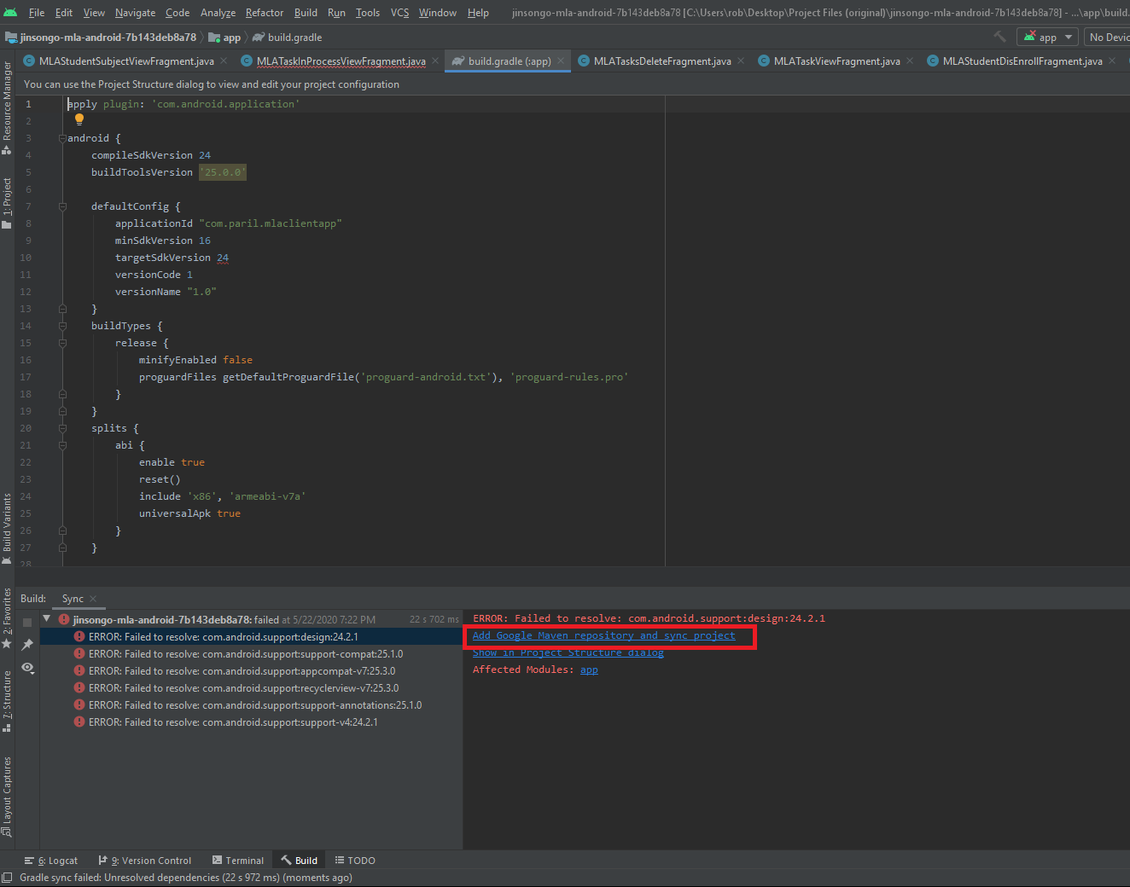

Refactor when adding the Google Maven repository.

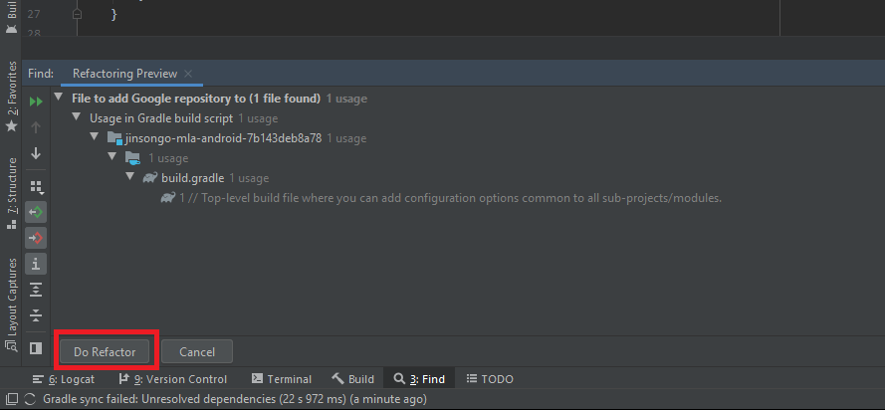

Go to *File -> Project Structure…*

In the *Project* section, change:

*Android Gradle Plugin Version* from *2.3.3* to *3.6.0*

*Gradle Version* from *3.3* to *5.6.4*

Click “Apply”, then hit “Okay”.

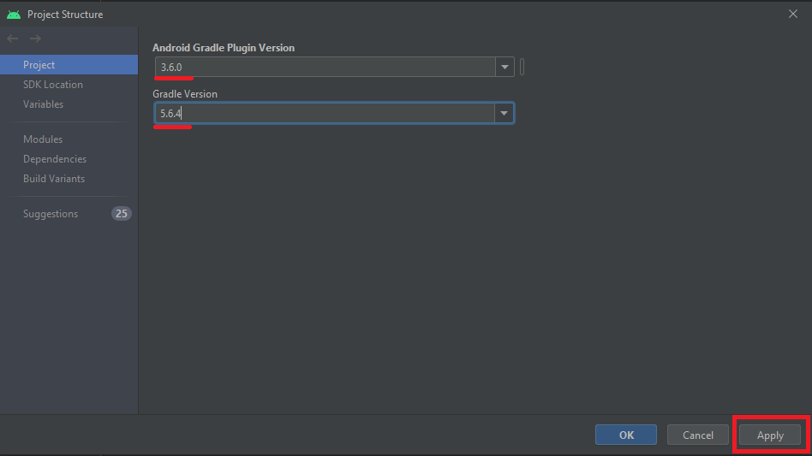

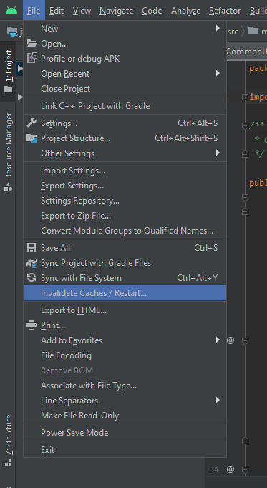

To ensure Gradle is synced properly with the changes, go to

*File -> Invalidate Caches/Restart*.

On the dialog box, select “Invalidate and Restart”

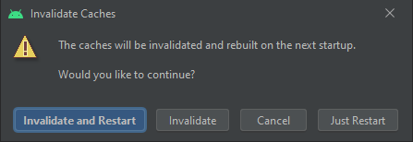

Add a new virtual device using AVD Manager by going to the device dropdown, and selecting “Open AVD Manager”

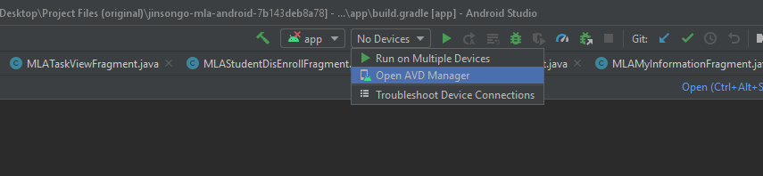

Select “+ Create New Virtual Device”

Select “Phone” on the left side (if not already selected), then select “Pixel 2” then click “Next”

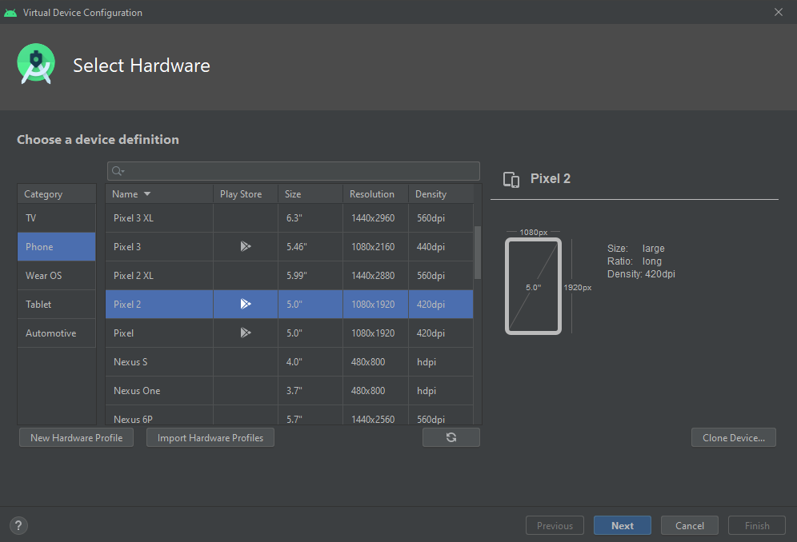

By default, it will recommend a x86 system image. THIS WILL NOT WORK.

Click the tab above the list and select “x86 images”. A list will come up with a variety of options, including x86_64 images. You can use any API level desired, but it MUST be an ABI of x86_64 AND the target MUST show “Google APIs”… not to be confused with Google Play. Download the image, and click “Next”.

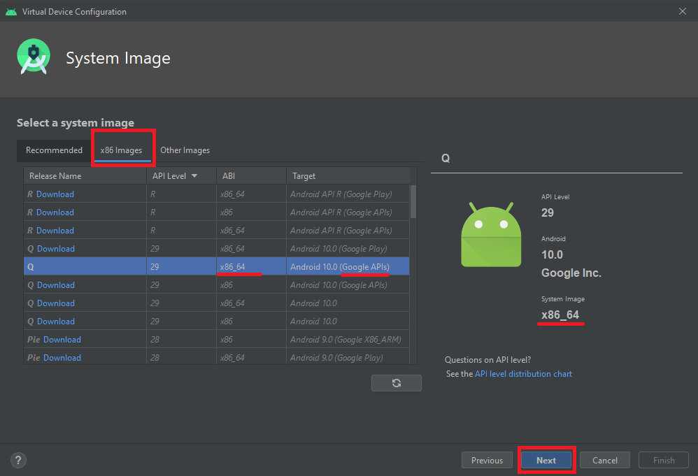

When you’re done, you should see the device in the list with the proper CPU/ABI and target.

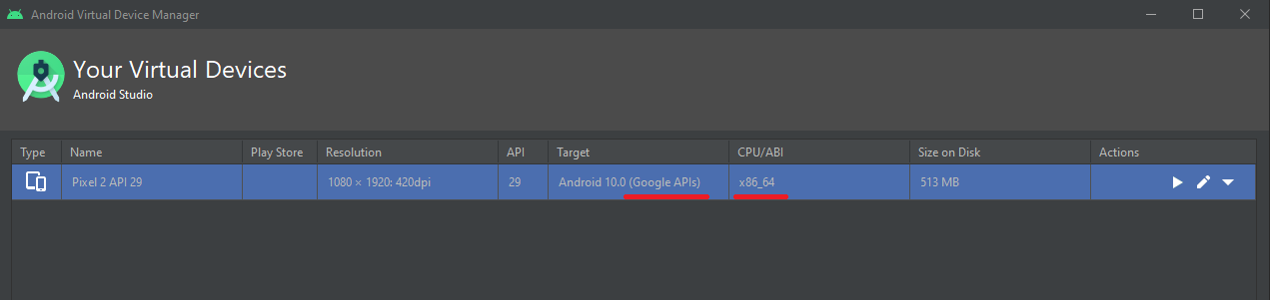

You can run the MLA app on your virtual device by selecting “run” on the toolbar.



If you get any error messages, do the *File -> Invalidate Caches/Restart* again.

It will take a while for the VM to boot and display the app.

